### PCS AUTOMATION

Project By

Name - Niranjan

Reg No – S200032700155

# NIIT

PCS Automation

Batch Code - S210167

Start Date - 11/11/20

End Date - 12/12/20

Name Of the Coordinator - Lopamudra Bera

Name Of the Developer - Niranjan V

Date of Submission - 12.12.2020

**NIIT**

###### CERTIFICATE

This is to certify that this report, titled PCS Automation embodies the original work done by Niranjan V, in partial fulfillment of his course requirement at NIIT.

Coordinator - Lopamudra Bera

**Acknowledgement**

I would like to thank my mentor Lopamudra Bera and also the institute NIIT who helped me achieve this project on Professionet Consultancy Services. It helped me to do a lot on the research on the project and the environment.

I am really thankful for the staffs for helping me around in learning a lot of information during my learning process.

**Abstract**

PCS Automation project helps to manage the employee portal and helps the company to register new employees to their company and would help their Employees to update their professional qualification on the company portal.

**Configuration**

Hardware - MacBook Pro (i9 processor) 16Gb RAM,

1TB Hard Disk.

Operating System - Mac Os Catalina X64

Software - Eclipse, MySQL, JRE..

**Table of Contents**

Chapter 1- Introduction

1. 1.0 Aim
2. 1.1 Objectives
3. 1.2 Case Study

Chapter 2- Project Requirement Specification

1. Literature Research
2. Statement of Requirements

Chapter 3- Project Analysis

1. Project Plan
2. System Architecture
3. Business Process Model
4. Software Requirement Specification
5. High Level Use Case Diagrams

Chapter 4- Project Design

1. Low Level Use Case Diagrams
2. User Interface Design
3. Systems Input and Output Design
4. Database Structure
5. Entity Relationship Diagram
6. Data Model
7. User-centered Interface Designs
8. Personas
9. Paper Prototypes

**Aim**

The Main aim of this Project is to create an application that can map all the employees of a company. Through this application an User can also register their application for a job inside the company.

Objectives:

The Objectives that are to be achieved through Skill Mapping Application are,

1. User Registration
2. Skill Map
3. Job Postings
4. Profile validation
5. Recruitment.

Before this application, these process were done manually.

Literature Research

Introduction:

In order to map the Job seekers who could have be seeking for a job with a lot of talent in them, this application is developed.

With this Application the HR consultants could find lot more talent during the recruitment process. HR consultants were doing this process manually. In that manual process HR would take a lot of time in order to sort the proper talent.

Statement of Requirements

Title - Pcs Automation

Subtitle - Employee management portal

Author - Niranjan V

Author’s Email - [niravignesh@gmail.com](mailto:niravignesh@gmail.com)

Description - Automated Consultancy service

About Your company:

Professionet consultancy services is a company which provides a wide range of business services to clients.

Need of Process Automation:

1. Saves a lot of time by making your process easy.
2. Improves the quality of your company
3. Helps to find the right talent
4. Adds quality to recruitment.

Software Requirements:

* Eclipse
* MYSQL
* JRE

Benefits:

* Pre-screening of candidates.
* Saves a lot of time to find the correct candidates.

Project Life Cycle

**The Initiation Phase :**

The initiation phase aims to define and authorize the project.

**The Planning Phase:**

The purpose of this phase is to lay down a detailed strategy of how the project has to be performed and how to make it a success.

Strategic Planning:

overall approach to the project

Implementation Planning:

ways to apply the decisions

**The Execution Phase:** In this phase, the decisions and activities defined during the planning phase are implemented.

**The Termination Phase:** This is the last phase of any project, and it marks the official closure of the project.

DataBase Structure

create table Employee (

empId int auto_increment,

FirstName varchar(30) not null,

LastName varchar(30) not null,

UserId varchar(30) not null,

Password varchar(20) not null,

Role varchar(3) not null,

Gender varchar(10) not null,

Active varchar(10) not null,

primary key(empId)

);

create table Skill(

SkillId int auto_increment,

SkillName varchar(30) not null,

SkillDescription varchar(30) not null,

Active varchar(10) not null,

primary key(SkillId)

);

create table Job(

JobId int auto_increment,

JobTitle varchar(30) not null,

JobDescription varchar(30) not null,

CompanyName varchar(30) not null,

Location varchar(30) not null,

KeySkill varchar(30) not null,

Salary Varchar(7),

Active varchar(10) not null,

primary key(JobId)

);

create table EmpSkill(

EsId int auto_increment,

EmployeeId int,

SkillId int,

ExpYear int not null,

foreign key (EmployeeId) references Employee (empId),

foreign key (SkillId) references Skill(SkillId),

primary key(EsId)

);

create table EmpJoB(

EJId int auto_increment,

EmployeeId int,

JobId int,

Recruited varchar(20) not null,

foreign key (EmployeeId) references Employee (empId),

foreign key (JobId) references Job (JobId),

primary key(EJId)

);

select * from Employee;

User Interface Design

Login Form:

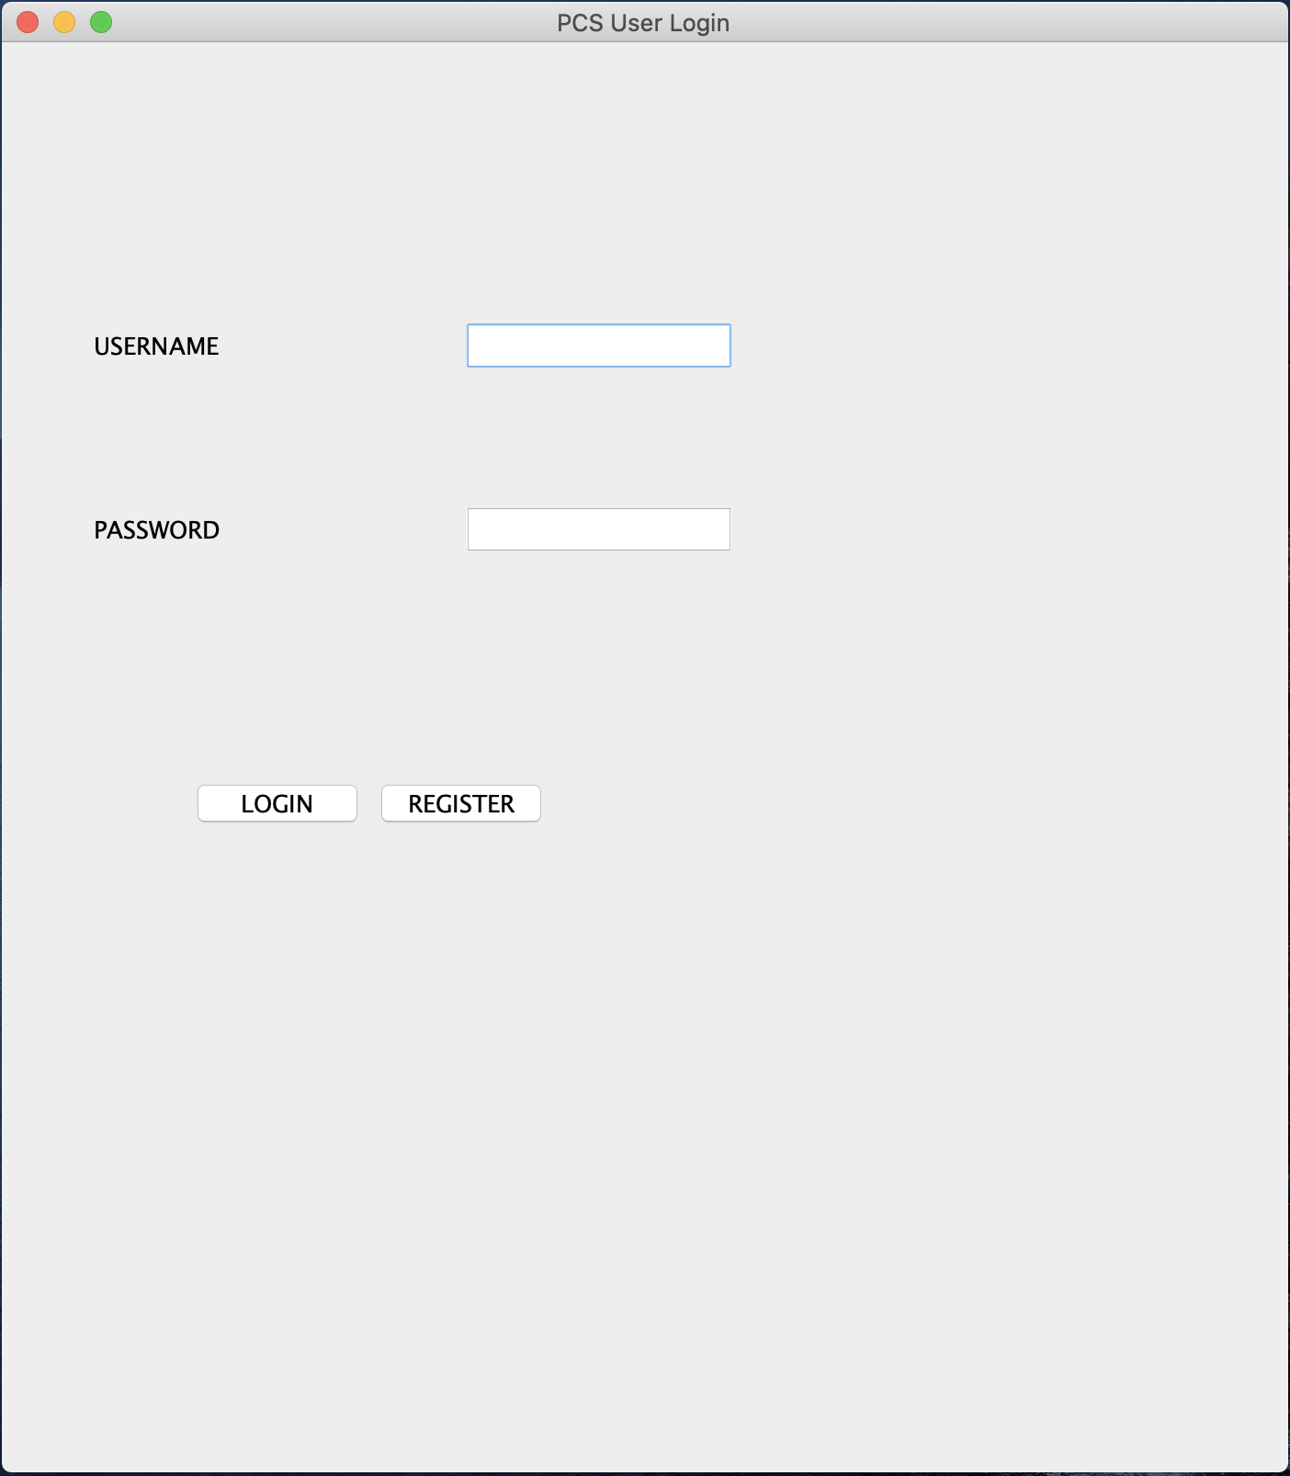

Registration Form:

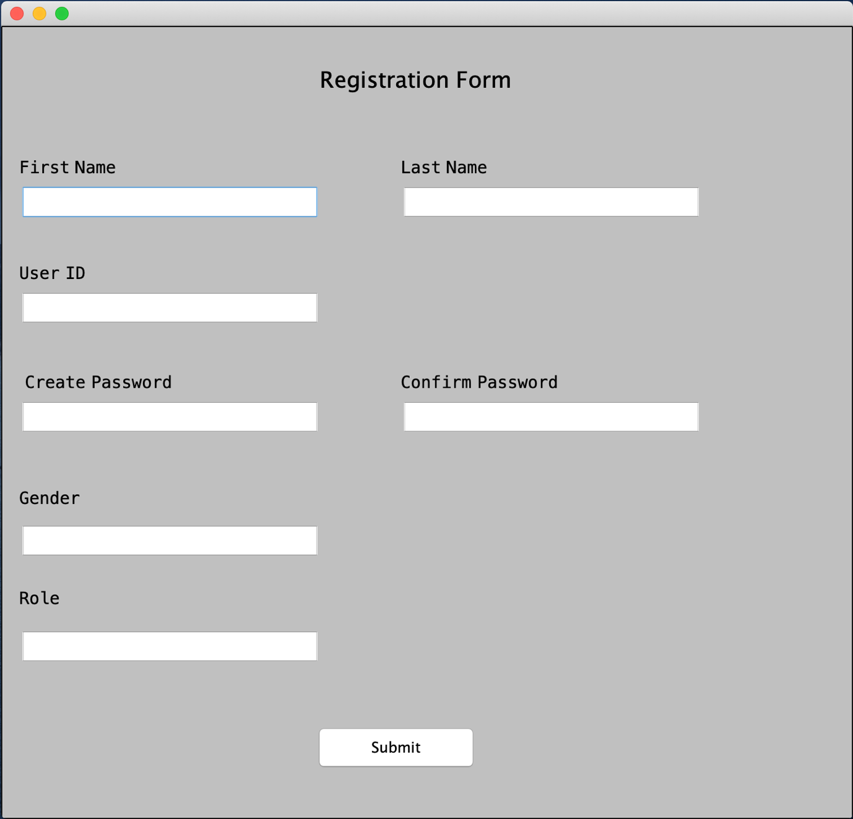

Employee Login:

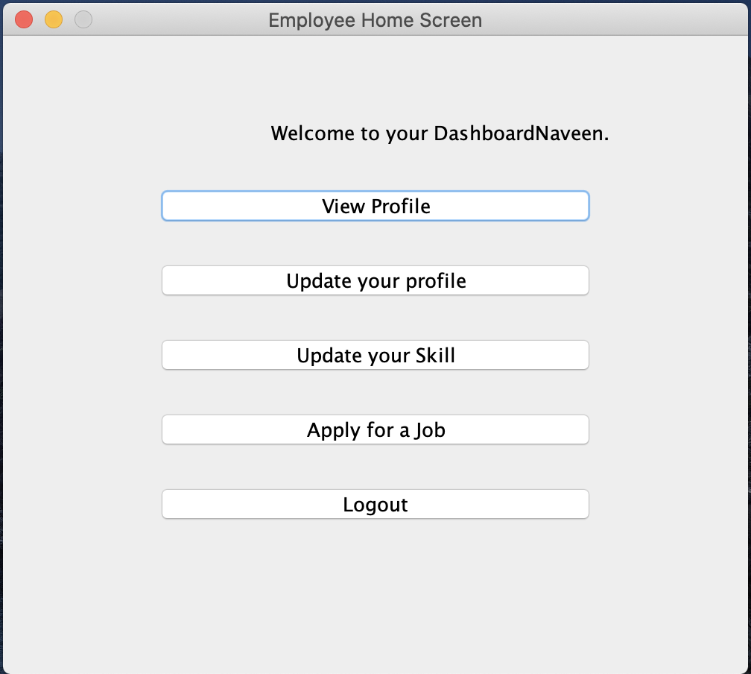

PME Login:

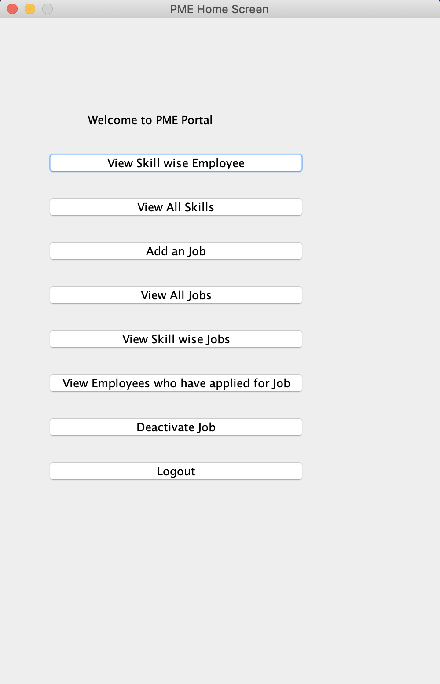

HRA Home:

